Counting Principles

* The product – Basic Product Principle (BPP)
  + If you are given certain cases and they occur one after another, if you get to choose from each of them, you can use product rule
  + EXAMPLE: How many even/odd 3 digits integers we can write?
    - _ _ _
    - 9.10.5 🡪 for even = we can write 450 even numbers
    - 9.10.5 🡪 for odd = we can write 450 odd numbers
  + BPP
    - If a procedure involves a sequence of k stages and let
      * ni = # of ways ith stage occurs
      * i = 1, …, k
    - BPP says the number of ways we can get that work done with k stage is:
      * n1 . n2 . … . nk
  + Cities and ways:
    - 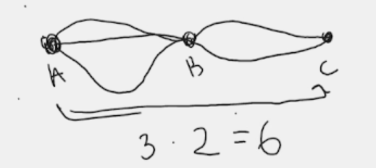
    - We can go from A to C in 6 different ways.
* Permutation
  + An ordered selection of r objects without repetition, take from n distinct objects is called a permutation of n objects taken r at a time.
  + r objects are chosen from n distinct objects.
  + Notation:
    - n P r
  + 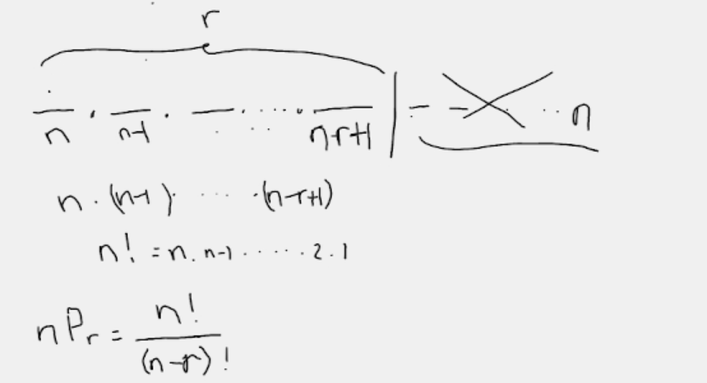
    - Cross ones are remaining ones that we didn’t use.
    - We multiply number of choices each time.



* + - Denominator erases the unnecessary part that we don’t use in combination.
  + 7P3 🡪 We have 7 objects and we choose 3 of them in a certain order.
    - Text, letter

      Description automatically generated
* Combination
  + We also select r objects from n objects. We don’t care about order, we care about what we choose.
  + A selection of r objects without regard to order and without repetitions, selected from n distinct objects is called combination of n objects taken r at a time.
  + # of such combinations:
    - Notation: n C r OR
  + EXAMPLE: In a 4 letter alphabet, lets show them with A, B, C, D. If we take 3 of them at a time:
    - The combinations (Order doesn’t matter):
      * 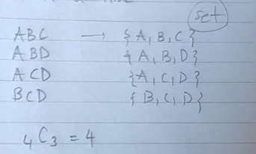
    - The permutations (Order matters):
      * 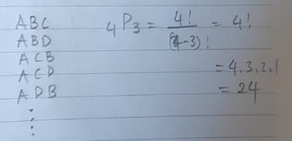
    - For one combination set, we could write 6 of them
      * Text

        Description automatically generated with low confidence



* + - * It means we can group the permutations corresponding to one combination.
      * n C r . r! = n P r
      * n C r = (n P r)/r!
      * 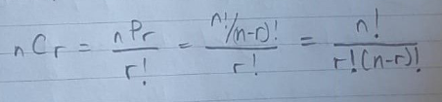
  + EXAMPLE: If a club has 20 members, how many different 4-member committees can be chosen?
    - Order doesn’t matter so we use combination
    - Graphical user interface

      Description automatically generated
  + Combination and Sets
    - For any nonnegative integer n,
      * 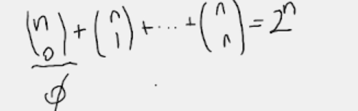
      * 2n is # of all subsets
      * 0 elemanlı alt küme, 1 elemanlı alt küme, …, n elemanlı alt küme sayıları
      * is set itself which is 1.
      * When we try to construct, lets say triangle, using some data points. How many of them we can construct is just an easy matter if you know this formula.
    - A subset E of S, (i.e. E S)
      * n C r = ---------> # of subsets with r elements of S of n elements
    - Combinations are connected with subsets and choosing certain number of elements.
    - Combinations are subsets.

Permutation with Repeated Objects

We have group of 5 people.

We have room A and B.

You want 3 of the people to assign to go to the room A and 2 of them to go room B.

People in room A and room B can be considered as same people. Think of mathematical way, not human way.

Repeated permutation:

* Text

  Description automatically generated with medium confidence
* Since we didn’t make any distinction between the 3 people in same room and 2 people in other room so we just use this kind of a reduction in the number.

The # of distinct permutations of n objects such that:

* n1 of them are a type
* …
* nk of them are another type
* ----------------------------------------
* n1 + n2 + … + nk = n
* number of repeated permutations:
* Since we repeat the same thing for each type, this is repeated permutation

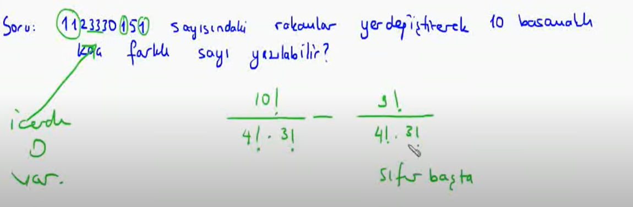Sıralanan şeylerin her biri birbirinden farklıysa 🡪 normal permütasyon (değilse sıralı)

SAMPLE SPACES AND EVENTS

***Sample Spaces:***

* A sample space S for an experiment is the set of all possible outcomes of the experiment (sth is happening and there are some possible outcomes).
* The elements of S are called sample points.
* If there is a finite number of sample points, that number is denoted #(S), and S is said to be a finite sample space.

Experiment:

* rolling a die 🡪 S = {1, 2, 3, 4, 5, 6}
* tossing a coin 🡪 S = {H, T}
* tossing 2 coins 🡪 S = {HH, HT, TH, TT}
  + 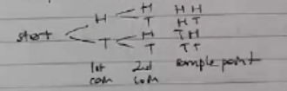

Example: Jelly Beans in a bag

* A bag contains 4 jelly beans: red, pink, black, white
  + A jelly bean is withdrawn at random, its color is noted, and it is put back in the bag. Then a jelly bean is again randomly withdrawn and its color is noted.
  + S = {RW, PB, WW, …}
  + 4.4 = 16 🡪 #(S) = 16
* If 2 jelly beans are selected without replacement?
  + #(S) = 4.3 = 12 OR 4P2 = 12

Example: Poker hand

* From an ordinary deck of 52 playing cards, a poker hand is dealt. Describe a sample space and determine the # of sample points.
  + A sample space consists of all combinations of 52 cards taken 5 at a time.
    - 52C5 = 2 598 960

***Events:***

* An event E for an experiment is a subset of the sample space for the experiment.
* If the outcome of the experiment is a sample point in E, then event E is said to occur.

Example:

* If the outcome of the rolling a single die is an even number:
  + S = {1, 2, 3, 4, 5, 6}
  + {2, 4, 6} = {x S ­| x is an even number}
  + We roll a die, if the outcome is a 2, that event occurs

Certain event:

* A sample space is a subset of itself, so it is an event.
* It must occur no matter what the outcome.

An event that consists of a single sample point is called a simple event.

{x S | x = 7} “7 occurs”

* This set contains no sample points, so S = is called impossible event bc it can never occur

Example:

* A coin is tossed 3 times 🡪 {HHH, HHT, …, TTT}
* Events:
  + a) E = {1 head and 2 tails} = {HTT, THT, TTH}
  + b) F = {at least 2 heads} = {HHH, HHT, HTH, THH}
  + c) G = {head on first toss} = {HHH, HTH, HHT, HTT}

**Venn Diagrams**

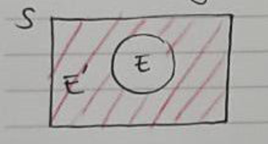S: a sample space

E: an event

E S

E’ = S \ E = {x S | x E} = the complement of E

S is superset of E.

Let E1 and E2 be two events

UNION: E1 U E2 = {x S | x E1 or x E2} -----> either in E1 or E2

INTERSECTION: E1 E2 = {x S | x E1 and x E2} -----> both in E1 and E2

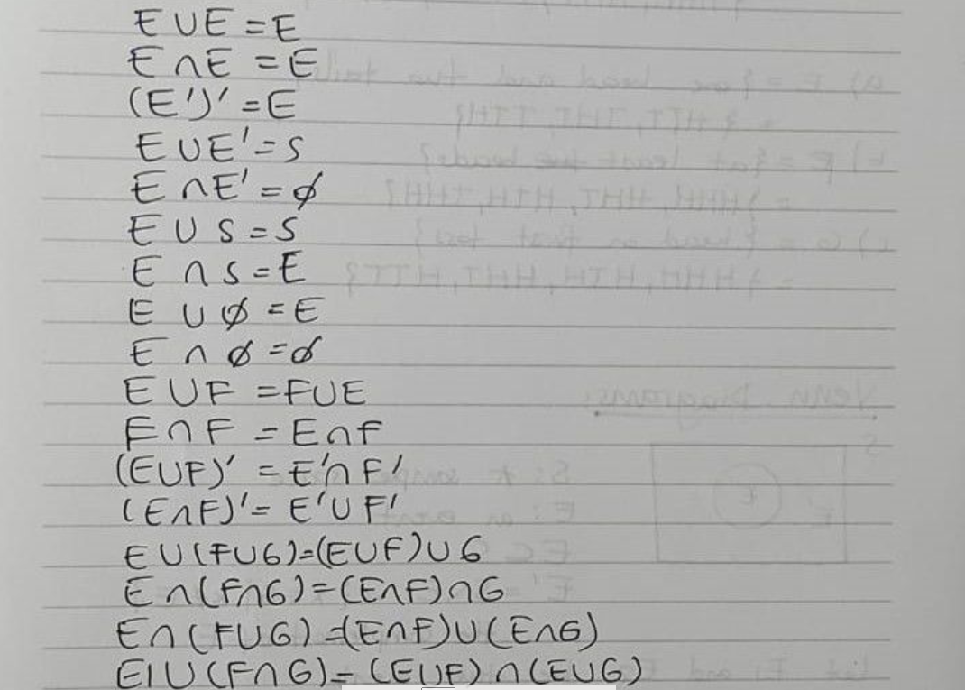Properties of events:

When two events E and F have no sample point in common, that is:

* E F =

they are called mutually exclusive or disjoint events.

Example:

* Rolling of a die E = {2, 4, 6}, F = {1} are mutually exclusive

Note: E and E’ are mutually exclusive, they both cannot occurs simultaneously.

Example:

* If E, F, G are events for an experiment and F,G are mutually exclusive.
* Show that E F and E G are also mutually exclusive.
* ---
* Given F G =
* We want to show that (E F)(E G) =
* 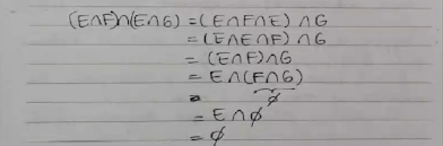

**PROBABILITY**

Consider tossing a fair die and obscuring the number that turns up.

S = {1, 2, 3, 4, 5, 6}

Each outcome has the same chance of occurring the outcomes equally likely.

Let the experiment be performed n times.

Each performance of an experiment is called a trial.

Suppose we are interested in the event of obtaining a 1. (E = {1} a simple event).

If a 1 occurs in k of these n trials, then the proportion of times that 1 occurs is k/n.

This ratio is called relative frequency of the event (how often sth happens).

If the die is a fair one, the probability of getting a 1 on the toss of a well-balanced die is:

* P(1) = 1/6 similarly P(2) = 1/6, … probability of each event is equal

In this experiment, all of the simple events in the sample space were understood to be equally likely to occur. To describe this equally likelihood, we say S is an equiprobable space.

A sample space S is called an equiprobable space if and only if all the simple events are equally likely to occur.

* well-balanced/unbiased die
* fair coin

If S is an equiprobable space with N (we usually use N for number of possible outcomes, size of sample space) sample points (or outcomes) s1, s2, …, sN, then the probability of the simple event {si} is given by P(si) = 1/N

for i = 1, 2, … N

* Note: P(si) = P({si})

Example:

* In the die experiment,
  + E: event of a 1 or a 2 turning up
    - E = {1, 2}
    - P(E) = 1/6 + 1/6 = 2/6

If S is a finite equiprobable space for an experiment, and E = {s1, s2, …, sj} is an event (all events are subset of a sample space), then the probability of E is given by:

* P(E) = P(s1) + P(s2) + … + P(sj)

or equivalently

* P(E) =

where

* #(E) = number of outcomes in E,
* #(S) = number of outcomes in S

P(E): relative frequency in a long run

* long run is a statistical term that means how many times you need to toss that coin to understand if there’s a fair or not.
* It is not easy to decide what is a long run.

Example:

* Coin tossing; Two fair coins are tossed,
* S = {HH, HT, TH, TT}
* The 4 outcomes are equally likely
* S is equiprobable
* #(S) = 4
* (a) two head occur
  + E = {HH}, then E is a simple event
  + P(E) = =
* (b) at least one head
  + E = {HH, HT, TH}
  + P(E) = P({HH}) + P({HT}) + P({TH}) = 1/4 + 1/4 + 1/4 = 3/4

Example:

* From a committee of 3 M and 4 F a subcommittee of 4 is to be randomly selected. Find the probability of that it consists of 2 M and 2 F.
* #(E) = # of ways 2 M and 2 F can be chosen
* #(S) = # of all committies with 4 members, so
* = = =

Properties of Probability

Let S be an equiprobable sample space with N outcomes

* #(S) = N

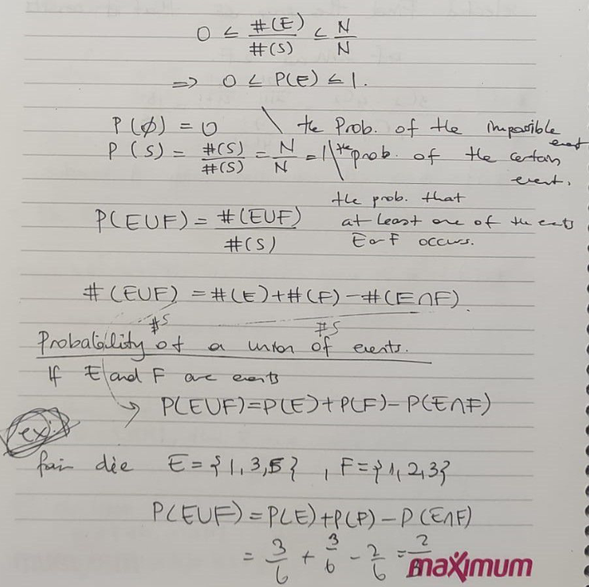If E is an event, then 0 <= #(E) <= N

Even size of the sample space is not certain, we can compute the probability. For example probability of the earthquake today or tomorrow. Sample space or event set is not certain.

If there are more than 1 event, check if there is an intersection or not like at the last example in last screenshot.

Addition Law for Mutually Exclusive Events

If E and F are mutually exclusive (there is no intersection):

* P(E U F) = P(E) + P(F)

Example (dice tossing):

* E = {2, 3}
* F = {1, 5}
* P(E U F) = P(E) + P(F) = 2/6 + 2/6 = 2/3

Example:

* If E, F, G mutually exclusive, = E F = E G = F G
* P(E U F U G) = P(E) + P(F) + P(G)

P(E U E’) = P(S) = 1

P(E) = 1 – P(E’)

P(E’) = 1 – P(E) -------> probability that E doesn’t occur

Event: Tossing 2 fair coins and observing # of heads.

* HH, HT, TH, TT
* S = {0, 1, 2}
  + We defined sample space as number of getting a head
* Simple events are not equally likely to occur
* P(0) = 1/4 P(1) = 2/4 P(2) = 1/4
* S is not equiprobable

Sırf fair diye equiprobable olmak zorunda değil!!!

Definition: Let S = {s1, s2, …, sN} be a sample space for an experiment. The function P is called a probability function if both of the followings are true:

1. 0 <= P(si) <= 1 for i = 1 to N
2. P(s1) + … + P(sN) = 1

We define probability, give the properties and then we can do the computation. This is why we need to define probability as function on sample space.

If E is an event, then P(E) is the sum of the probabilities of the sample points in E.

We define P() = 0

Any function P that satisfies condition 1 & 2 above is a probability function for a sample space.

Example:

* Experiment of tossing two fair coins and observing number of heads:
  + S = {0, 1, 2}
  + P(0) = 0.1 P(1) = 0.2 P(2) = 0.7
  + It seems like coins are not fair. We can still use in the computation.

A probability function satisfies:

* P(E’) = 1 – P(E)
* P(S) = 1
* P(E1 U E2) = P(E1) + P(E2) if E1 E2 =

Emprical Probability

So far we learned theoretical probability bc outcomes are equally likely.

Suppose, the coin is not fair. By tossing the coin a number of times, we can determine relative frequencies of H and T occurring.

n = 1000

Emprical probabilities:

* P(H) = 517/1000
* P(T) = 483/1000

If outcomes are not equally likely, we can still use them in the computation.

Example:

* The probabilities (empirical) are assigned on the basis of sample data
* An opinion poll of a sample of 150 adult residents of a town was conducted. Each person was asked his or her opinion about floating a bond issue to build a community swimming pool.
* Results:

T: total

* Suppose an adult resident from the town is randomly selected. Let:
  + a) P(M) = 80 / 150 = 8 / 15
  + b) P(+) = 100 / 150 = 2 / 3
  + c) Males favor the bond issue: P(M +) = 60 / 150 = 2 / 5